BUSINESS PROPOSAL
Brandon Starks
Carlotta Persaud
DBM/294
January 21, 2017

DATABASE MANAGEMENT BUSINESS PROPOSAL
Currently no work order or ticketing system exists within our organization. As a result, neither planned or ad hoc service is prioritized, communicated, or accounted for on a regular basis. In fact, we do not currently know how long our current planned work would take us because we have no handle on the time commitments of our project – not service – workload. As a result, dissatisfaction is growing both among our internal customers as well as our service employees.
As a solution to this issue A work ticketing system should be built within a database management system. Such a system will help to collect and organize information we need as a snapshot of where we currently sit regarding work-hour commitments, allow us to better plan and track our commitments in the future, and serve as a transparent communications channel with our internal customers allowing them to see the status and priority of their request as well as those priorities which we set above their own. The overall design of the database proposed to solve this business problem is as follows:
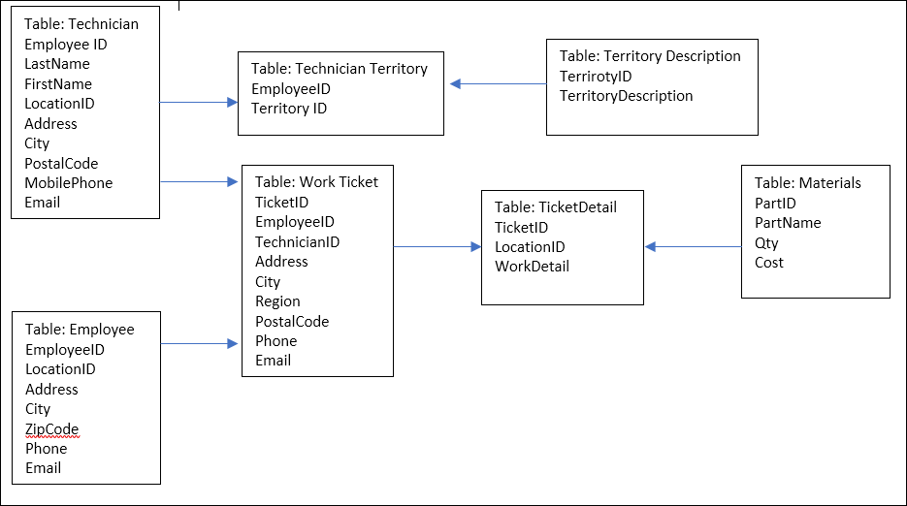

Below is a description of what each table should represent and it’s need within the new system:
Table 1: Technician Table
EmployeeID (Primary Key) | LocationID (Foreign Key)
Integer | Integer
Concept: This table will identify the specific Technician who is assign to individual work tickets. This will allow the list of technicians to be updated independent of other ticket information.

Table 2: Technician Territory

EmployeeID (Foreign Key) | TerritoryID (Primary Key)
Integer | Integer
Concept: Allows list of technicians to be manipulated by ID and track metrics for certain areas. For example, if a business were extending their branching network into a new territory this would allow a comparison between it and an existing region.

Table 3: Table: Territory Description

TerritoryID (Primary Key) | TerritoryDescription
Integer | ntext
Concept: Create profile of a territory to compare similarities and differences when comparing territory metrics. This is a seldom used Table and can be held alone for an indexing optimization function.

Table 4: Employee

EmployeeID (Primary Key) | LocationID (Foreign Key)
Integer | Integer
Concept: Table will allow to match work tickets with the employee who requested work done.

Table 5: WorkTicket

TicketID (Primary Key) | EmployeeID | TechnicianID (Foreign Key)
Integer | Integer | Integer
Allows ticket to be assigned to a technician.

Table 6: TicketDetail

TicketID | LocationID (Primary Key) | WorkDetail
Integer | Integer | ntext
Concept: Allows information to be provided to the technician working on the ticket. This is created in a separate table as an indexing function for database optimization.

Table 7: Materials

ParkID (Primary Key) |  | PartName
Integer |  | nvarchar200
Concept: Allows specific parts to be assigned to work for activity based accounting purposes. In the future, could be tied into an hourly cost for further accuracy. Could also be included in an inventory system or asset management system.

